|  |  |
| --- | --- |
| **WC Logo.emf** | **Staff Report to the Weber County Commission**  *Weber County Planning Division* |
|  | |

****Synopsis****

****Application Information****

**Application Request:** Public hearing to consider and take action on a request to vacate the North East (rear) and South East (side) property line public utility easements on Lot 11 of the Uintah Highlands Subdivision No. 6.

**Agenda Date: Tuesday, September 20, 2022**

**Applicant:** Scott & Nancy Waterfall, Owner

**File Number:** EV 2021-07

****Property Information****

**Approximate Address: 2060 East** Ryan Circle, Ogden

**Project Area:** Variable

**Zoning:** R-2

**Existing Land Use:** Residential

**Proposed Land Use:** Residential

**Parcel IDs:** 07-434-0004

**Township, Range, Section:** T5N, R1W, Section 23, NW

****Adjacent Land Use****

**North:** Residential **South:** Residential

**East:** Residential **West:** Residential

****Staff Information****

**Report Presenter: Scott Perkes**

[sperkes@co.weber.ut.us](mailto:sperkes@co.weber.ut.us)

**801-399-8772**

**Report Reviewer:** SB

Background and Summary

The applicant (Scott Waterfall) has submitted a request to vacate the public utility easements along the North East (rear) and South East (side) property lines on Lot 11 of the Uintah Highlands Subdivision No.6 (See **Attachment A**).

The applicant has also submitted an application to vacate the originally requested easements, and has included as part of the application a letter from Rocky Mountain Power that releases interest in the requested easement. The County Engineering Division has approved of the proposed easement vacation.

Additional Analysis

*General Plan*: The vacation of unutilized easements is not anticipated to have a negative effect on the 2022 Western Weber General Plan.

*Additional Consideration*: The Uintah Highlands Subdivision No. 6 was recorded in September of 1993. During subdivision approval of this plat, the developer proposed to have 10 foot public utility easements along the front, rear, and side property lines of each lot in the subdivisions for potential utility placement. However, with exception to storm drain lines that run along some lots in Ryan Circle (between lots 12 & 13, and 17 & 18), it appears that all utilities serving each of the lots on Ryan Circle were only placed within the front lot line easements.

*Public Notice*: Public noticing and the noticing of potentially affected entities has been provided as outlined in state code Section 17-27a-208.

Commission Considerations

The applicant has proposed to vacate the public utility easements by ordinance. Under the state code, Section 17-27a-609.5, the legislative body may adopt an ordinance granting a petition to vacate some or all of a public street, right-of-way, or easement if the legislative body finds that:

(a) good cause exists for the vacation; and

(b) neither the public interest nor any person will be materially injured by the vacation.

Staff Recommendation

The proposed easements could be vacated should the Commission find the following:

1. Vacating the identified easements will not have a negative effect on the Western Weber General Plan
2. The public interest or any person will not be materially injured by the proposed vacations.
3. The vacations will not be detrimental to the public health, safety, or welfare.
4. The vacations will not deteriorate the environment of the general area so as to negatively impact surrounding properties and uses.

If granted, the requested vacations may be formalized through execution of the enclosed Vacation Ordinance (see **Attachment E**).

Attachments

1. Vacation Application
2. Original Uintah Highlands 6 plat
3. Draft Ordinance

Area Map

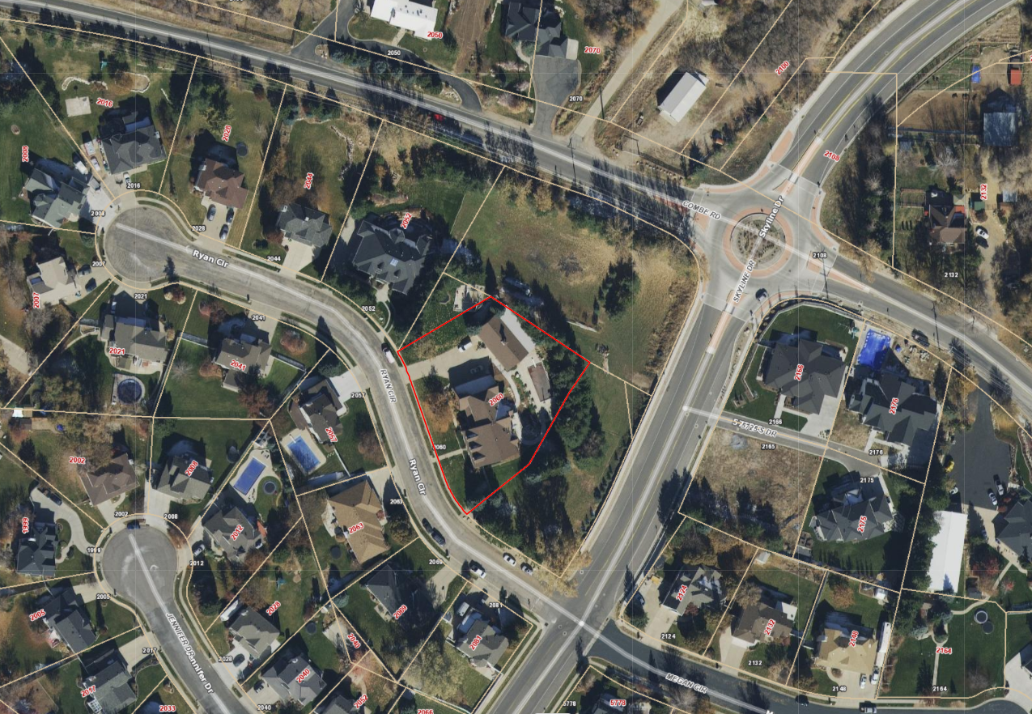

Attachment A: Vacation Application

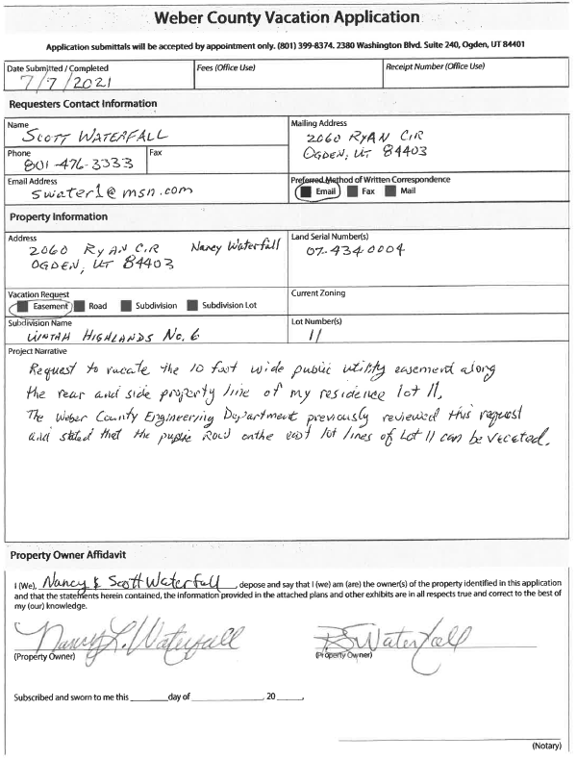

Attachment B: Original Uintah Highlands 6 Plat

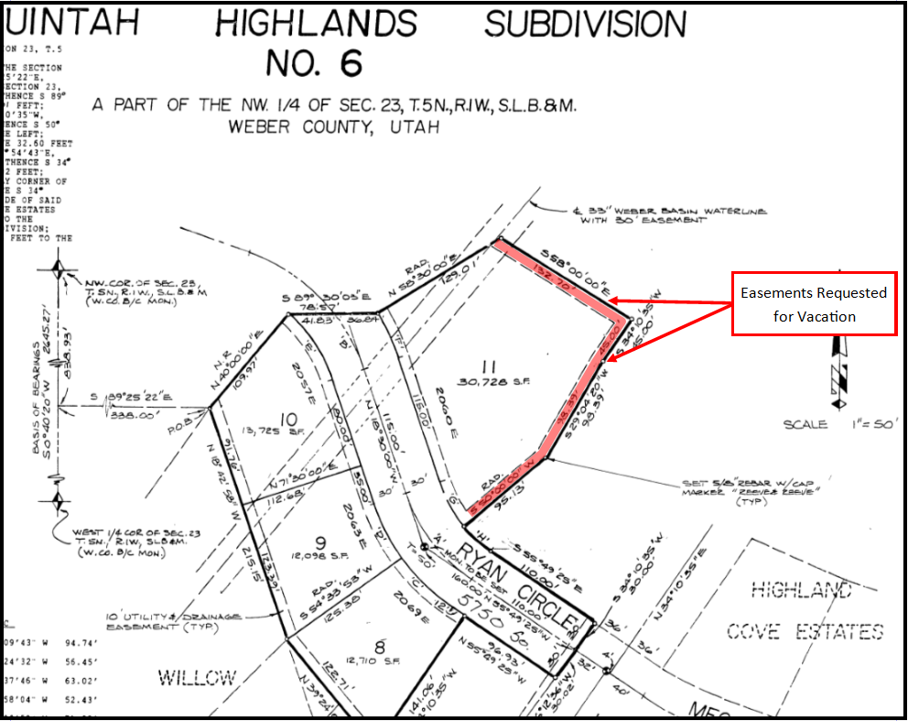

Attachment E: Draft Vacation Ordinance

